Buying Smart in Neighborhood ABC:
Sale Prices, Outliers, and Value in 1,460 Home Sales

Case Study Report, Assignment 3

Qingan Xu
MSSP 607
30 November 2026

Executive Summary
My clients plan to buy a home in neighborhood ABC and asked for an analysis of what homes there sell for, along with advice on how to buy. This report examines all 1,460 recorded sales in the neighborhood, describes the level and spread of prices, tests for outliers that could distort the picture, and turns the results into a buying strategy.
The mean sale price is $180,921.20, and the standard deviation is $79,442.50. Because prices are right-skewed, the mean overstates what a typical buyer pays: the median home sold for $163,000, and half of all homes sold for between $129,975 and $214,000. Sixty-one sales above $340,037.50 are statistical outliers, but they are genuine luxury homes, so I kept them and reported medians alongside means; on their own they raise the mean by about $10,700 and the standard deviation by about $20,200. Two other sales—new homes of 4,676 and 5,642 square feet that sold for $40 and $28 per square foot—are anomalies that distort what size and quality appear to be worth, so I excluded them from the valuation model.
That model explains 86% of the variation in (log) sale price using quality, living area, garage capacity, age, condition, and central air, and it estimates a typical home’s value to within about 9%. It shows that buyers pay little extra for quality up to grade 7 but steeply more above it.
I recommend that the clients focus on homes rated 6 or 7 for quality that have central air and a garage for at least two cars—typically $165,000 to $215,000 for about 1,550 square feet—and that they anchor every offer to a fair-value estimate. In this segment, one sale in five closed at least 10% above estimated value, with a median overpayment of $31,858; pricing offers against value is the most direct way to avoid that outcome.

Introduction
My clients are preparing to buy a home in neighborhood ABC and want to understand the local market before making an offer. They asked three questions: What are the mean and standard deviation of home prices? What does the distribution of prices look like? Are there unusual sales that could distort the analysis, and how should they be handled? Behind these questions lies the decision the clients actually face—which kind of home to buy, and how much to pay for it.
The evidence is a data set of 1,460 home sales (HousingPrices.csv). For each sale it records the price and 15 characteristics of the home and the sale, including overall quality and condition ratings on a 1–10 scale, living and basement area, lot size, year built, central air, garage capacity, and year sold (see app. A). The file is a subset of the training data from Kaggle’s House Prices competition (Montoya and DataCanary), which originates in Dean De Cock’s record of residential property sales in Ames, Iowa, from 2006 to 2010 (De Cock 1). The assignment treats all of the sales as one neighborhood and describes the data as fictitious, so the findings illustrate an analytical approach rather than describe a real market.
Two features of the data shape the analysis. First, prices were stable: the median sale price ranged only from $155,000 to $167,000 across the five sale years, although those years spanned the national housing downturn (see app. B, fig. 6). Second, several characteristics are incomplete, most notably basement area, which is missing for 37.5% of homes. I answer the clients’ three questions with descriptive statistics, a histogram, and standard outlier tests, then use a hedonic pricing model—which treats a home’s price as the sum of implicit prices for its characteristics (Rosen 34)—to estimate what each feature is worth and what a given home should cost. All calculations appear in the accompanying Jupyter notebook, written in Python with pandas (McKinney), NumPy (Harris et al.), SciPy (Virtanen et al.), and Matplotlib (Hunter); it runs from top to bottom in Google Colab and reproduces every number, table, and figure in this report.

Key Issues, Goals, and Problems
The clients’ goal is to buy a home that meets their needs at a fair price and that will be easy to resell. Four issues stand between them and that goal:
- Setting a realistic budget. In a skewed market the average price can mislead, so the clients need to know what a typical home costs and how widely prices vary.
- Separating signal from noise. A handful of unusual sales can distort averages and relationships; they must be identified and handled deliberately rather than ignored or deleted.
- Knowing what features are worth. Quality, size, garages, and central air all raise prices, but the clients need to know by how much in order to decide which features to pay for.
- Judging a specific asking price. Even homes with the same features sell for different prices, so a buyer who cannot tell a fair price from an inflated one risks overpaying.

Decision Criteria
I evaluate buying strategies against five criteria:
- Affordability: price relative to the typical (median) home in ABC.
- Value for money: price per square foot, and asking price relative to the home’s estimated value.
- Lasting features: quality grade, central air, and garage capacity, which carry measurable price premiums and support resale value.
- Market depth: the segment’s share of sales; more comparable sales mean more reliable pricing and more future buyers.
- Valuation risk: how closely prices in the segment follow estimated values; the wider the spread, the easier it is to overpay.

Assumptions
The analysis rests on five assumptions:
- The recorded sales are arm’s-length transactions that represent the ABC market, apart from the two anomalous sales identified below.
- Percentage relationships, such as the premium for central air, carry over to today’s market even though dollar prices have changed since 2006–2010.
- The clients are owner-occupiers with a mid-market budget who care about resale value; they have not stated a specific budget.
- Quality and condition ratings are applied consistently from home to home.
- Characteristics missing from the data, such as exact location and interior finishes, do not differ systematically between the segments compared.

Limitations of the Data
The data limit how far the results can be pushed. The file contains 15 of the 79 explanatory variables in the original Kaggle data (Montoya and DataCanary) and omits building type (detached house or townhouse), sale condition (normal, foreclosure, or partial sale), location within the neighborhood, and interior features such as kitchen quality. Without sale condition, distressed or partial sales cannot be identified directly, which matters whenever a home looks unusually cheap.
Missing values are substantial. Basement area is missing for 547 homes (37.5%), lot frontage for 259 (17.7%), and lot area for 119 (8.2%); only 694 homes (47.5%) have all three. The gaps in lot frontage are not random—homes without it sold for more (median $172,400 versus $159,500; Mann–Whitney p = 0.009)—so filling them with an average would bias the results (Little and Rubin). Finally, the sales date from 2006 to 2010, quality and condition are subjective ratings, and the model’s estimates are associations rather than guarantees: adding a garage will not automatically raise a home’s value by the premium the model attaches to garages.

Data Analysis
This section summarizes the analysis. Supplementary charts and model output are in the appendices, and the full code is in the notebook.

Question 1: Average Price and Spread
The mean sale price is $180,921.20, and the standard deviation is $79,442.50 (see table 1). The standard deviation equals 44% of the mean, a wide spread for a single neighborhood. A minority of expensive homes pulls the mean upward, so the median of $163,000 and the interquartile range of $129,975 to $214,000 better describe what a typical buyer will pay.
Table 1
Descriptive Statistics for Sale Price, Neighborhood ABC (n = 1,460)
Statistic | Value
Mean | $180,921.20
Standard deviationª | $79,442.50
Median | $163,000
25th–75th percentile | $129,975–$214,000
Minimum–maximum | $34,900–$755,000
Coefficient of variation | 43.9%
Skewness | 1.88
Source: Author’s calculations from HousingPrices.csv (Montoya and DataCanary).
a Sample standard deviation (divisor n − 1); the population value is $79,415.29.

Question 2: Distribution of Prices
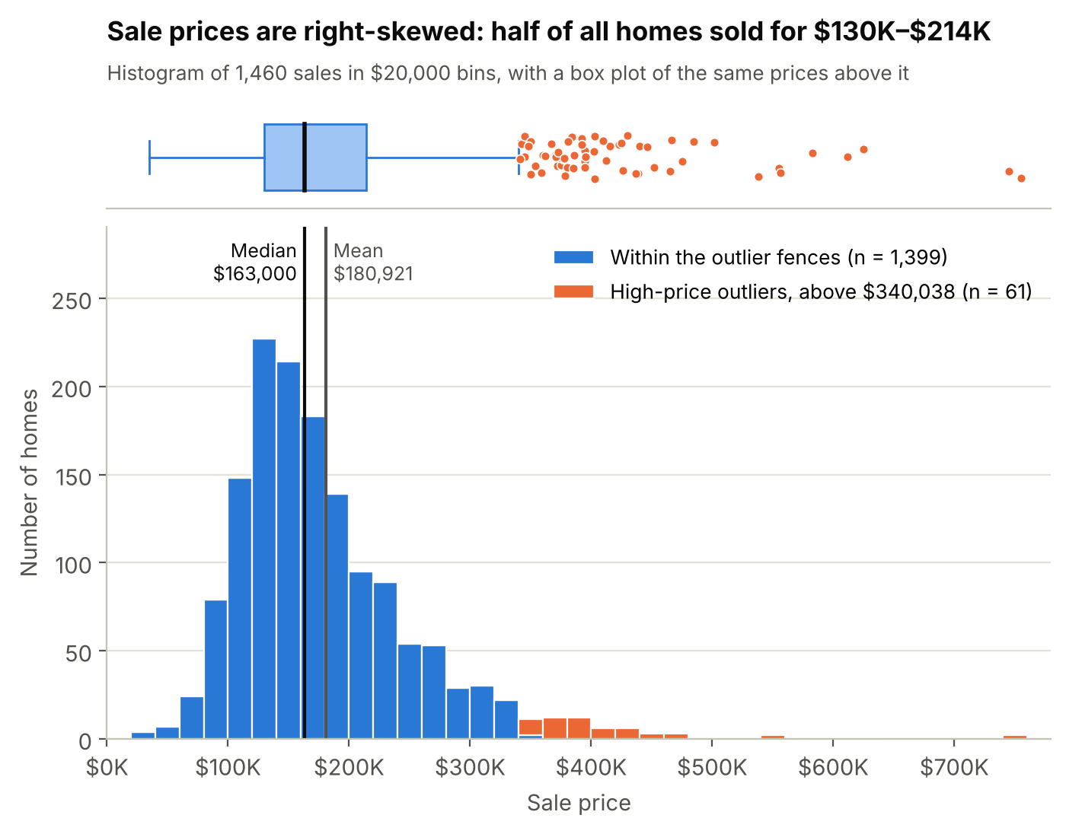
Fig. 1. Distribution of sale prices in $20,000 bins, with a box plot above and outliers in orange; author’s chart from HousingPrices.csv (Montoya and DataCanary).
Figure 1 shows the distribution of prices. Sales form a single peak, with the tallest bars between $120,000 and $160,000, and 77% of homes sold for $100,000 to $250,000. The right tail stretches to $755,000, while the cheapest home sold for $34,900, so the distribution is right-skewed (skewness of 1.88) rather than bell-shaped. On a logarithmic scale the same prices are nearly symmetric (skewness of 0.12; see app. B, fig. 4), which is why the valuation model below works with the logarithm of price.

Question 3: Outliers and How They Were Handled
I tested for two kinds of outliers: prices that are extreme in themselves, and sales whose prices are out of line with the homes sold.
Extreme prices. Tukey’s box-plot rule flags values more than 1.5 interquartile ranges beyond the first or third quartile (Tukey). By this rule, 61 homes (4.2%) priced above $340,037.50 are outliers, and no price falls below the lower fence. These are not errors: every one is rated 7 or higher for quality, and the typical one is a 2,364-square-foot home built in 2006 with a three-car garage. They are the top of the ABC market, so I kept them. They do, however, distort the summary statistics (see table 2). Without them, the mean would fall by $10,684 and the standard deviation by $20,212, while the median would move by only $3,500. I handled them in three ways: by reporting the median and quartiles alongside the mean and standard deviation, by modeling the logarithm of price, which compresses the long tail, and by treating high-quality homes as a separate segment when comparing buying strategies.
Table 2
Effect of the 61 High-Price Outliers on Summary Statistics
Statistic | All homes  (n = 1,460) | Without outliers  (n = 1,399) | Change
Mean | $180,921.20 | $170,237.13 | −$10,684.07 (−5.9%)
Standard deviation | $79,442.50 | $59,230.13 | −$20,212.37 (−25.4%)
Median | $163,000 | $159,500 | −$3,500 (−2.1%)
Interquartile range | $84,025 | $74,500 | −$9,525 (−11.3%)
Skewness | 1.88 | 0.68 | −1.20
Source: Author’s calculations from HousingPrices.csv (Montoya and DataCanary).
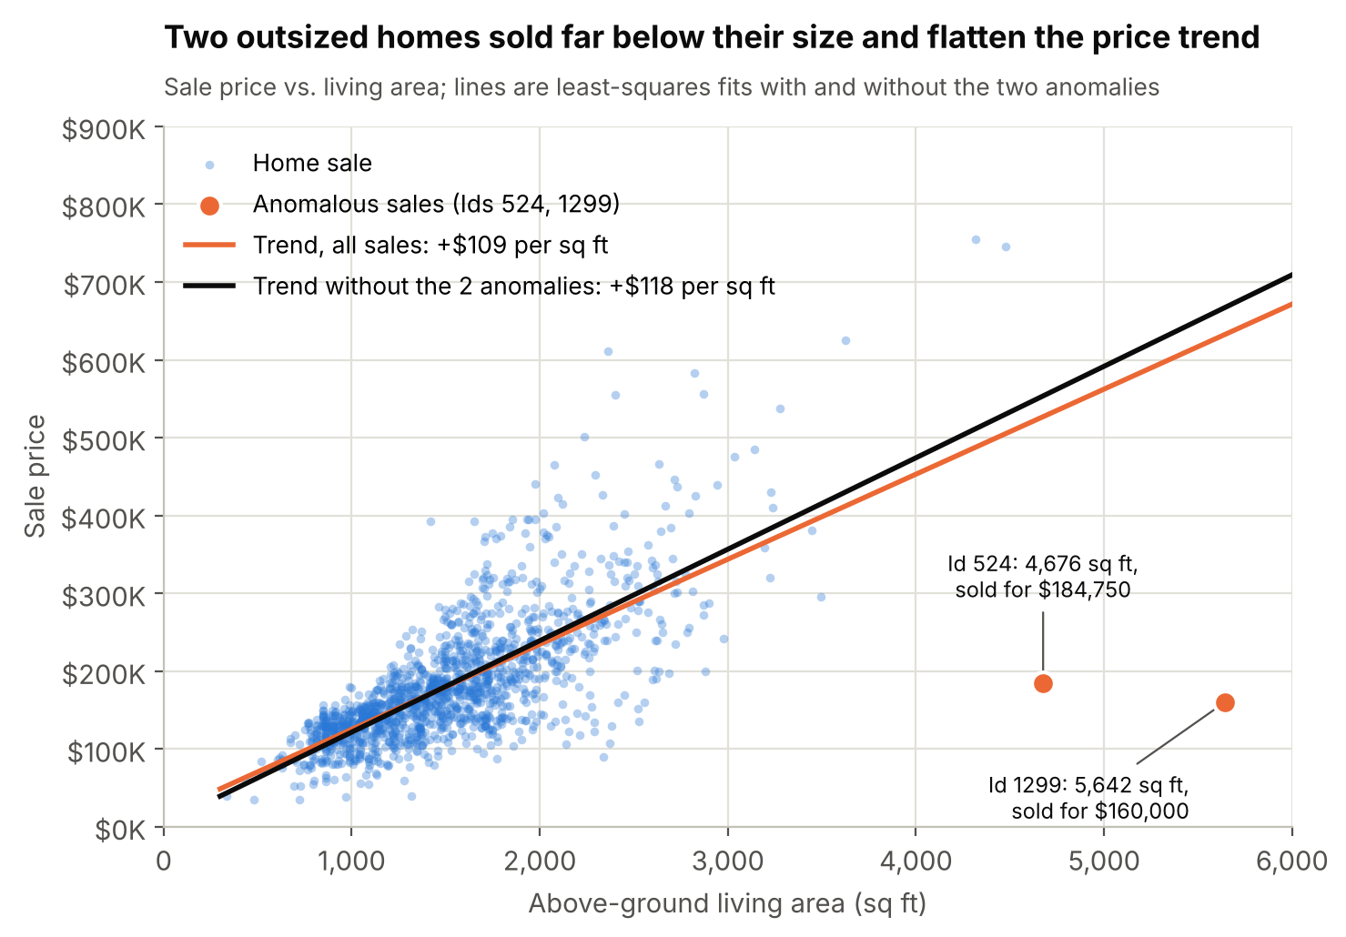
Fig. 2. Sale price versus living area, with trend lines fitted with and without the two anomalous sales (orange); author’s chart from HousingPrices.csv (Montoya and DataCanary).
Out-of-line sales. Two sales stand apart from the relationship between size and price (see fig. 2). The homes with IDs 524 and 1299 are new, top-quality houses of 4,676 and 5,642 square feet, each sold in the year it was built, for $184,750 and $160,000—$40 and $28 per square foot, against a median of $174 for all quality-10 homes. Their prices are unremarkable on their own, so the box-plot rule misses them, but they have by far the largest Cook’s distances in the valuation model (0.35 and 0.24, against 0.06 for the next-largest home), a measure of how much one observation shifts a fitted model (Cook). They match De Cock’s description of partial sales among the largest homes in the original data, sales that “likely don’t represent actual market values” (4). Including them lowers the estimated value of an extra square foot from $118 to $109 and cuts the model’s premium for quality-10 homes from 80% to 57%. I kept them in the descriptive statistics for questions 1 and 2, since they are recorded sales, but excluded them from the valuation model.
Missing values. Rather than drop the 52% of homes with at least one gap, I left the three incomplete characteristics out of the main model. Adding basement area or lot area back in, for the homes where they are recorded, raises the model’s explanatory power only modestly (R² of 0.87 to 0.88 instead of 0.85 to 0.86) and changes none of the conclusions (see app. C).

What Drives Price
Overall quality is the characteristic most closely associated with price (Pearson correlation of 0.79), followed by living area (0.72) and garage capacity (0.64; see app. B, fig. 5). Because these features tend to come together (newer homes are also larger and more likely to have central air), I estimated a hedonic regression of the logarithm of price on quality grade, living area, garage capacity, year built, condition, and central air, a functional form widely used in housing research because each coefficient translates into a percentage effect on price (Malpezzi). The model explains 86% of the variation in log price, and in fivefold cross-validation its typical estimate falls within 9% of the actual sale price (see app. C, fig. 7).
Table 3 converts the main results into dollars for a median-priced home. Central air adds about 11%, each garage space about 8%, each point of condition about 6%, and 10% more living area about 5%. Condition illustrates why the model matters: on its own, condition is slightly negatively correlated with price, because most new homes carry an average rating, but among homes of the same age and quality, better condition commands a clear premium.
Table 3
Estimated Price Effects of Home Features, Other Features Held Constant
Feature | Effect on price | Value for a  $163,000 home
Central air (versus none) | +11.3% | $18,363
Each additional garage space | +8.0% | $12,971
Each additional point of condition | +6.2% | $10,029
10% more living area | +5.0% | $8,090
Built 10 years later | +3.6% | $5,850
Quality grade 7 (versus grade 6) | +9.3% | $15,143
Quality grade 8 (versus grade 6) | +28.0% | $45,705
Source: Author’s regression of log sale price on 1,458 sales, excluding the two anomalous sales; full results in appendix C.
The most decision-relevant result concerns quality (see fig. 3). Compared with an otherwise identical quality-6 home, a quality-5 home sells for 3% less and a quality-7 home for 9% more, but quality-8, quality-9, and quality-10 homes command premiums of 28%, 59%, and 80%. In other words, moving up one grade costs about 3.5% from grade 5 to grade 6 and 9% from 6 to 7, but 17% from 7 to 8 and 24% from 8 to 9. Better construction is cheapest to buy in the middle of the quality range.
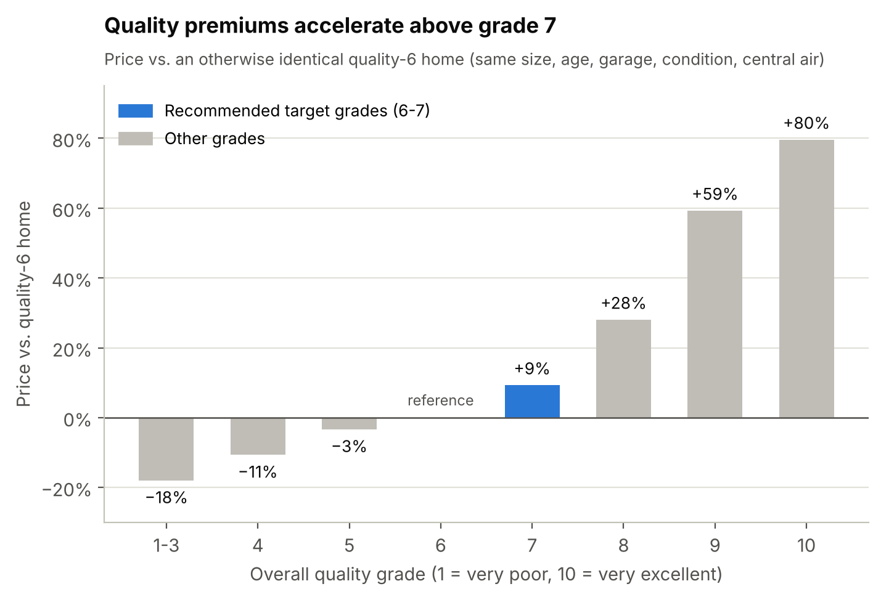
Fig. 3. Estimated price of each quality grade relative to an otherwise identical quality-6 home; author’s regression of HousingPrices.csv (Montoya and DataCanary).

Preferred Alternative and Rationale
I compared three buying strategies, defined by quality grade, against the decision criteria (see table 4).
Strategy A, an entry-level home, has the lowest price and the lowest price per square foot, but it buys a small, older home (a median of 1,120 square feet, built in 1957) that often lacks central air or a two-car garage, and its value is harder to estimate. Strategy C buys the best construction, but at $151 per square foot—27% more than strategy B—in a thin market that accounts for only 16% of sales and in which valuations are least precise, so it is easier both to overpay and, later, to wait for a buyer.
Table 4
Three Buying Strategies Compared against the Decision Criteria
Criterion | A. Entry  (grades 1–5) | B. Mid-quality  (grades 6–7) | C. High-quality  (grades 8–10)
Share of sales (homes) | 37% (538) | 47% (693) | 16% (229)
Median price | $127,750 | $178,900 | $285,000
Middle 50% of prices | $108,000–$143,000 | $151,000–$208,900 | $245,350–$342,643
Median living area | 1,120 sq. ft. | 1,512 sq. ft. | 1,915 sq. ft.
Median price per sq. ft. | $111 | $119 | $151
Median year built | 1957 | 1984 | 2004
Central air | 87% | 97% | >99%
Garage for two or more cars | 41% | 82% | 99%
Typical valuation errorª | 9.0% | 8.3% | 9.8%
Source: Author’s calculations from HousingPrices.csv (Montoya and DataCanary).
a Median absolute difference between sale price and model-estimated value, excluding the two anomalous sales.
Strategy B is the preferred alternative because it performs best on the decision criteria as a whole. Its median price ($178,900) sits within 10% of the market median. It costs only 7% more per square foot than an entry home, yet 97% of these homes have central air and 82% have a garage for two or more cars. It is the deepest segment, with nearly half of all sales, which gives buyers plenty of comparable sales to price against and many future buyers when they sell. Finally, its prices follow estimated values most closely. The economic rationale comes from the hedonic results: the market charges little for the step from grade 5 to grade 6 and moderately for the step to grade 7, but far more for each step above that, so grades 6 and 7 deliver the most quality per dollar. Within this segment, I recommend screening for homes rated 6 or 7 that have central air and a garage for at least two cars. That screen matches 554 sales (38% of the market), with a median price of $185,800 and a middle half of $165,000 to $215,000.

Recommendations and Predicted Outcome
I recommend that the clients take five steps:
- Budget from the median, not the mean. Plan around the $163,000 median and the $130,000–$214,000 middle of the market; the $180,921 mean is inflated by a small number of luxury sales.
- Target grade 6 or 7 with central air and a two-car garage. These homes offer the cheapest quality upgrades, the deepest resale market, and the most predictable prices.
- Price every listing against its estimated value. Before making an offer, estimate the home’s value from its quality, size, age, condition, garage, and central air, and compare it with recent comparable sales. Treat an asking price more than 10% above the estimate as open to negotiation unless the home has value the model cannot see, such as a finished basement or a large lot.
- Give credit for maintenance. Holding age and quality constant, each point of condition adds about 6% (roughly $10,000 on a median-priced home). That premium can still buy good value in a well-kept older home: homes built from 1971 to 1990 sold for a median of $122 per square foot, against $140 for homes built after 2000.
- Scrutinize bargains. A large or high-quality home priced far below its estimated value may reflect a partial, distressed, or non-market sale, or a need for major repairs. The data cannot tell these cases apart, so the clients should inspect the home and confirm the terms of sale before bidding.
If the clients follow these recommendations, they can expect to buy a home of roughly 1,550 square feet, built in the mid-1990s, with central air and a two-car garage, for about $165,000 to $215,000. The fair-value test protects them on price. Among the 554 homes that fit the screen, 115 (21%) sold for at least 10% more than their estimated value, a median overpayment of $31,858, while 104 (19%) sold for at least 10% less, a median saving of $26,648. A buyer who declines to pay well above estimated value avoids the first outcome and, with patience, can aim for the second. Because the analysis rests on prices from 2006 to 2010, the dollar figures should be refreshed with current comparable sales; the recommendation itself depends on relative values, which assumption 2 takes to carry over to today’s market.

Conclusion
Homes in neighborhood ABC sold for an average of $180,921.20, with a standard deviation of $79,442.50, but the typical home sold for $163,000, and the long right tail of the distribution means the mean overstates what most buyers pay. The histogram and outlier tests show that 61 luxury sales form that tail; they are genuine and were kept, while two sales of very large homes at a fraction of market value were set aside so that they would not distort the valuation model. The model shows that quality is the strongest driver of price and that its premium rises steeply above grade 7. For the clients, the implication is clear: the best value lies in quality-6 and quality-7 homes with central air and a two-car garage, bought at or below a fair-value estimate. That combination balances affordability, value for money, resale depth, and pricing risk better than either entry-level or high-end homes.
Works Cited
Cook, R. Dennis. “Detection of Influential Observation in Linear Regression.” Technometrics, vol. 19, no. 1, 1977, pp. 15–18, https://doi.org/10.1080/00401706.1977.10489493.
De Cock, Dean. “Ames, Iowa: Alternative to the Boston Housing Data as an End of Semester Regression Project.” Journal of Statistics Education, vol. 19, no. 3, 2011, https://doi.org/10.1080/10691898.2011.11889627.
Harris, Charles R., et al. “Array Programming with NumPy.” Nature, vol. 585, no. 7825, 2020, pp. 357–62, https://doi.org/10.1038/s41586-020-2649-2.
Hunter, John D. “Matplotlib: A 2D Graphics Environment.” Computing in Science & Engineering, vol. 9, no. 3, 2007, pp. 90–95, https://doi.org/10.1109/MCSE.2007.55.
Little, Roderick J. A., and Donald B. Rubin. Statistical Analysis with Missing Data. 2nd ed., Wiley, 2002.
Malpezzi, Stephen. “Hedonic Pricing Models: A Selective and Applied Review.” Housing Economics and Public Policy, edited by Anthony O’Sullivan and Kenneth Gibb, Blackwell Science, 2002, pp. 67–89.
McKinney, Wes. “Data Structures for Statistical Computing in Python.” Proceedings of the 9th Python in Science Conference, edited by Stéfan van der Walt and Jarrod Millman, 2010, pp. 56–61, https://doi.org/10.25080/Majora-92bf1922-00a.
Montoya, Anna, and DataCanary. “House Prices—Advanced Regression Techniques.” Kaggle, 2016, www.kaggle.com/c/house-prices-advanced-regression-techniques/data. Accessed 2 Nov. 2026.
Rosen, Sherwin. “Hedonic Prices and Implicit Markets: Product Differentiation in Pure Competition.” Journal of Political Economy, vol. 82, no. 1, 1974, pp. 34–55, https://doi.org/10.1086/260169.
Tukey, John W. Exploratory Data Analysis. Addison-Wesley, 1977.
Virtanen, Pauli, et al. “SciPy 1.0: Fundamental Algorithms for Scientific Computing in Python.” Nature Methods, vol. 17, no. 3, 2020, pp. 261–72, https://doi.org/10.1038/s41592-019-0686-2.

Appendix A: Data Dictionary
Table 5 lists the 17 columns in HousingPrices.csv. Definitions follow the Kaggle data description (Montoya and DataCanary); the missing-value counts are from the author’s analysis.
Table 5
Variables in HousingPrices.csv
Variable | Description | Missing values
Id | Sale identifier | 0
SalePrice | Sale price in dollars | 0
LotFrontage | Linear feet of street connected to the property | 259 (17.7%)
LotArea | Lot size in square feet | 119 (8.2%)
HouseStyle | Style of dwelling (for example, one story, two story, split level) | 0
OverallQual | Overall material and finish, from 1 (very poor) to 10 (very excellent) | 0
OverallCond | Overall condition, from 1 (very poor) to 10 (very excellent) | 0
YearBuilt | Original construction year | 0
TotalBsmtSF | Total basement area in square feet | 547 (37.5%)
CentralAir | Central air conditioning (Y or N) | 0
1stFlrSF | First-floor area in square feet | 0
2ndFlrSF | Second-floor area in square feet (0 if none) | 0
FullBath | Full bathrooms above grade | 0
TotalRooms | Rooms above grade, not counting bathrooms | 0
GarageCars | Garage size in car capacity (0 if no garage) | 0
GarageArea | Garage size in square feet | 0
YrSold | Year of sale (2006–2010) | 0
Source: Definitions adapted from Montoya and DataCanary; missing-value counts are the author’s.

Appendix B: Supplementary Figures
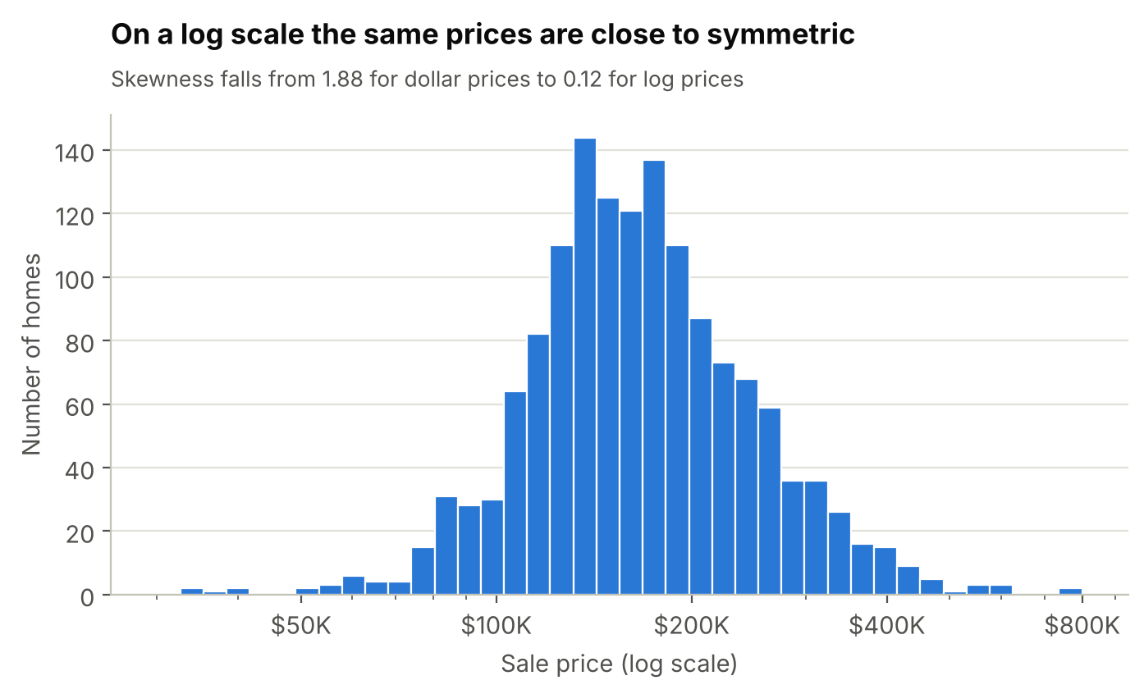
Fig. 4. Distribution of sale prices on a logarithmic scale; author’s chart from HousingPrices.csv (Montoya and DataCanary).
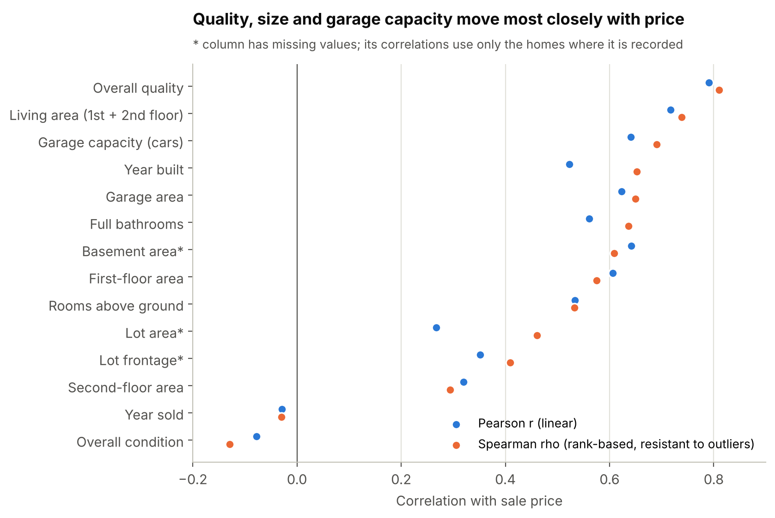
Fig. 5. Correlation of each characteristic with sale price; asterisks mark characteristics with missing values; author’s chart from HousingPrices.csv (Montoya and DataCanary).
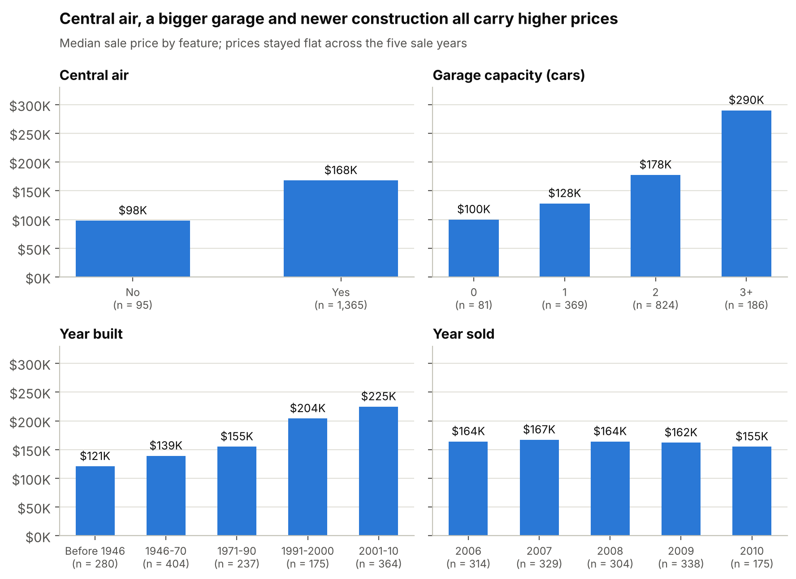
Fig. 6. Median sale price by central air, garage capacity, construction era, and year of sale; author’s chart from HousingPrices.csv (Montoya and DataCanary).

Appendix C: Regression Results and Robustness Checks
Table 6 reports the hedonic regression used throughout the report, table 7 compares it with alternative specifications, and figure 7 compares its estimates with actual sale prices.
Table 6
Hedonic Regression of the Logarithm of Sale Price (n = 1,458)ª
Term | Coefficient | Standard error | Effect on price
Intercept | 0.768 | 0.452 | —
Quality grade 1–3 (versus 6) | −0.198 | 0.035 | −18.0%
Quality grade 4 | −0.113 | 0.018 | −10.7%
Quality grade 5 | −0.034 | 0.012 | −3.3%
Quality grade 7 | 0.089 | 0.013 | +9.3%
Quality grade 8 | 0.247 | 0.016 | +28.0%
Quality grade 9 | 0.466 | 0.027 | +59.3%
Quality grade 10 | 0.586 | 0.041 | +79.6%
Log of living area | 0.508 | 0.016 | +5.0% per 10%
Garage capacity (cars) | 0.077 | 0.007 | +8.0% per car
Year built | 0.0035 | 0.0002 | +0.35% per year
Overall condition | 0.060 | 0.004 | +6.2% per point
Central air | 0.107 | 0.019 | +11.3%
Source: Author’s estimates from HousingPrices.csv (Montoya and DataCanary), excluding the two anomalous sales.
a R² = 0.856; adjusted R² = 0.855; residual standard deviation = 0.152. Every coefficient except the intercept is statistically significant at p < 0.01. The effect on price is exp(coefficient) − 1 for a one-unit change; for living area it is the effect of a 10% increase, 1.10 raised to the coefficient, minus 1.
Table 7
Robustness of the Main Results to Outliers and Missing Data
Specification | Homes | R² | Living-area  elasticity | Quality-8  premium | Quality-10  premium
Main model (two anomalous sales excluded) | 1,458 | 0.856 | 0.51 | +28% | +80%
All sales included | 1,460 | 0.843 | 0.49 | +29% | +57%
Main model plus basement areaª | 913 | 0.869 | 0.49 | +22% | +55%
Main model plus log of lot area^{b} | 1,339 | 0.879 | 0.44 | +29% | +78%
Source: Author’s estimates from HousingPrices.csv (Montoya and DataCanary).
a Homes with basement area recorded; each additional 100 square feet of basement adds 1.8% to price.
b Homes with lot area recorded; a 10% larger lot adds 1.2% to price.
In fivefold cross-validation, in which each home’s value is estimated by a model fitted without that home, the median absolute error is 9.0% (8.9% in sample), 55% of estimates fall within 10% of the sale price, and 85% fall within 20%, so the model is not overfitted. In every specification in table 7, each feature’s effect keeps its positive sign, and the cost of moving up one quality grade rises at each step from grade 5 to grade 9.
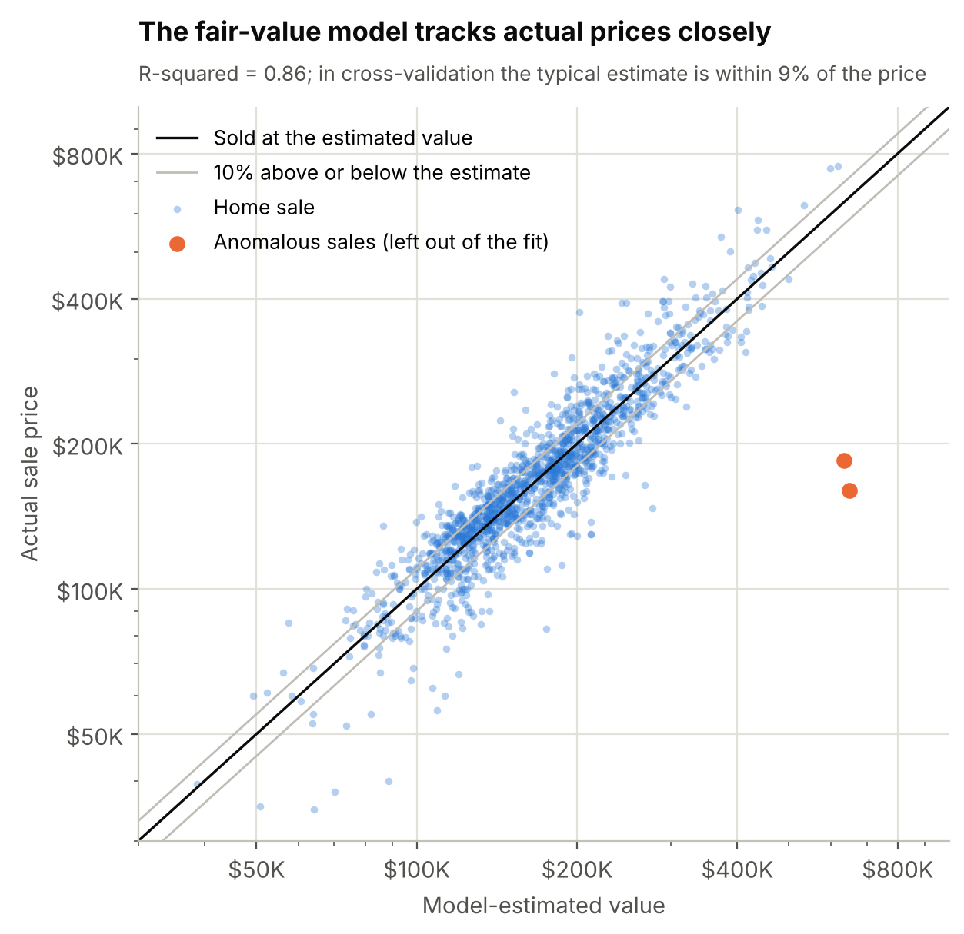
Fig. 7. Actual sale price versus model-estimated value; gray lines mark 10% above and below the estimate, and the two anomalous sales (orange) were not used to fit the model; author’s chart from HousingPrices.csv (Montoya and DataCanary).

